Q: If Convolution is applied image is shrink or expond?

Ans: Image is shrink, like 6 by image and filter 3 by3 is shrink to 4 by 4.

Q: How to solve the image shrinking problem, because in deep neural network up to 100 layers image size very small?

Ans: We apply padding, means before any convolution operation we can apply padding.

Q: Write the formula of padding and with padding?

Ans: nxn is image and fxf filter is convolved output is (n-f+1)x(n-f+1) image size is reduced.

With padding (n +2p – f +1)X(n + 2p – f + 1).

Q: What is the meaning of Valid and Same Padding?

Ans: Valid means no padding and we use this formula (n-f+1)x(n-f+1), image size is shrink and Same means add padding and I/P and O/P image size is same, we use this formula (n +2p – f +1)X(n + 2p – f + 1).

Q: What is Strided Convolution?

Ans: In Simple convolution you jump one column at a time and multiply and take sum, but if Stride is 2 means you can shift 2 columns at once than multiply and sum.

Q: If image size is 7x7 and convolve with filter 3x3 and Stride is 2, Padding is zero, than output image is?

Ans:

$$\left( \frac{n+2p-f}{S}+ 1\right)×\left( \frac{n+2p-f}{S}+ 1\right)$$

$$= \left( \frac{7+2*0-3}{2}+ 1\right)*\left( \frac{7+2*0-3}{2}+ 1\right)=3 ×3$$

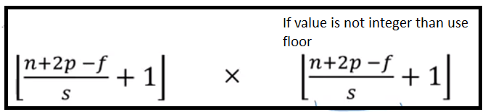

Q: What is the difference between Convolution and Correlation?

Ans: In Convolution Shift, Multiply and Summation, but in Correlation first flip and shift and then multiply and then Summation.

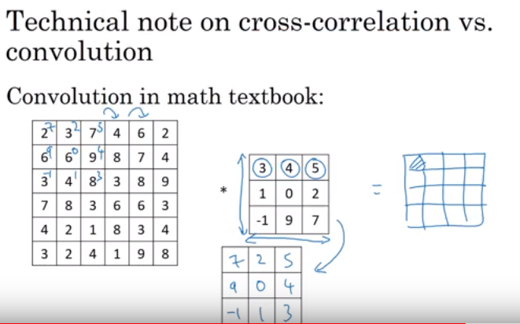

Q: Is it necessary that Number of channels in image and number of channels in Filter is same?

Ans: No of channels in image is the same as number of channels in filter both are equal to 3.

